Andrew Gazin

100207068

CPSC 1181

Assignment 4

Clock

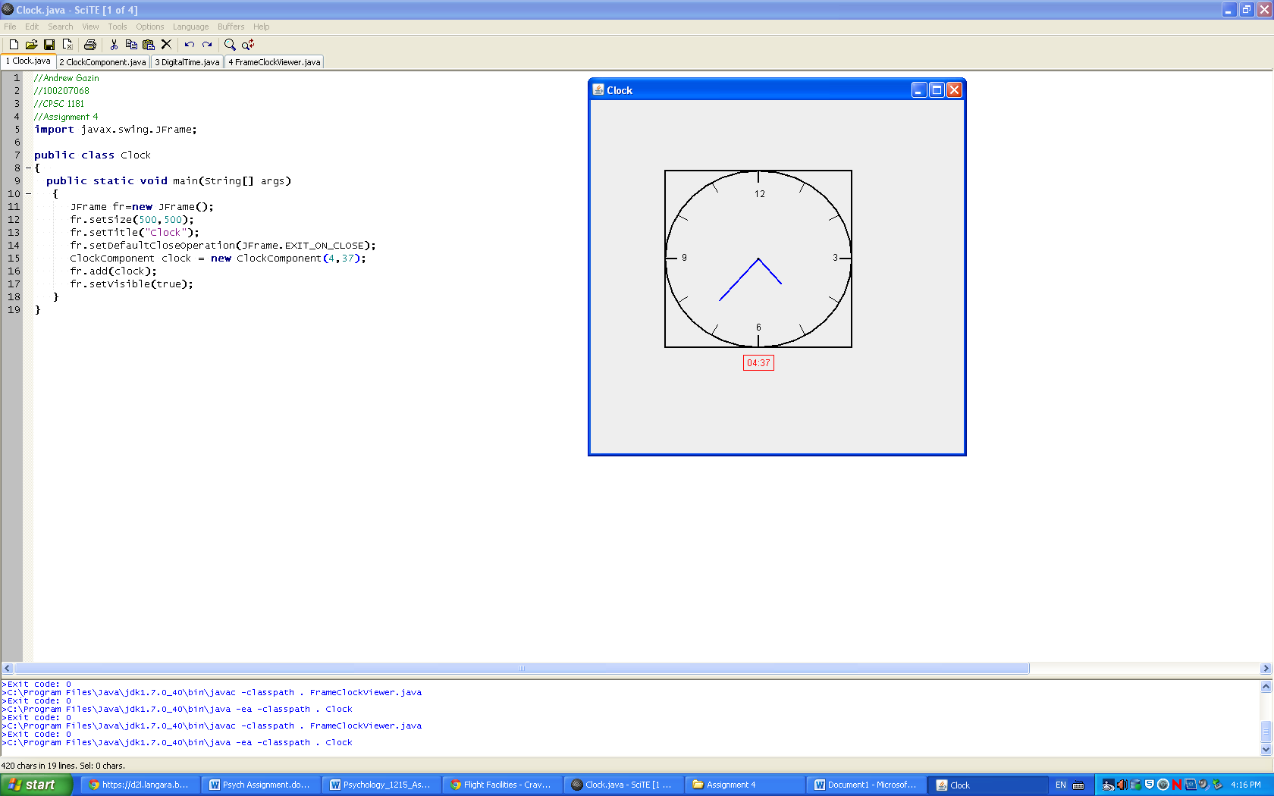

In the FrameClockViewer.java file, I have the numbers all in comments because I could not get them to move with the screen the way I wanted them to. So I left them in the comments.